Internship Project Report on

A Project Based on GATE PASS MANAGEMENT SYSTEM

A report submitted as a part of the industrial Orientation Training in IT & ERP Department. Visakhapatnam Steel Plant.

By
BATTULA LAKSHMI NARAYANA PRADEEP
VANDANA VIVEK VARDHAN
SASANKA SEKHAR SATAPATHY
GONTHINI VENKATA TARUN KUMAR
VARRI NIKSHITHA
DATTI SRAVYA
PASALA UMESH SRI CHANDRA
MIRTHIPATI RAHUL

Department of Information Technology
Under the guidance of


V. HEMA SUNDAR RAO (DGM)

RASHTRIYA ISPAT NIGAM LIMITED (RINL), Visakhapatnam
(Duration: 12th May 2025 to 07th June 2025)

CERTIFICATE

This is to certify that the allowing Students of ANDHRA UNIVERSITY COLLEGE OF ENGINEERING VISAKHAPATNAM, DADI INSTITUTE OF ENGINEERING AND TECHNOLOGY, NIST UNIVERSITY BERHAMPUR, ANDHRA UNIVERSITY COLLEGE OF ENGINEERING FOR WOMEN VISAKHAPATNAM, MAHARAJA VIJAYARAM GAJAPATHI RAJ COLLEGE OF ENGINEERING are engaged in the project work sided A Project Band Gate pass management system from 12th May 2025 to 07th June 2025.
BATTULA LAKSHMI NARAYANA PRADEEP
VIVEK VARDHAN
SASANKA SEKHAR SATAPATHY
GONTHINI VENKATA TARUN KUMAR
NIKSHITHA
SRAVYA
PASALA UMESH SRI CHANDRA
MIRTHIPATI RAHUL

In partial Fulfilment of the degree BACHELORS OF TECHNOLOGY in COMPUTER SCIENCE ENGINEERING stream in ANDHRA UNIVERSITY COLLEGE OF ENGINEERING VISAKHAPATNAM, DADI INSTITUTE OF ENGINEERING AND TECHNOLOGY, NIST UNIVERSITY BERHAMPUR, ANDHRA UNIVERSITY COLLEGE OF ENGINEERING FOR WOMEN VISAKHAPATNAM, MAHARAJA VIJAYARAM GAJAPATHI RAJ COLLEGE OF ENGINEERING is a record of Bonafide work carried out by an under the guidance and supervision during the period from 19th may 2025 to 12th June 2025

Date:
Place: Visakhapatnam

V. HEMA SUNDAR RAO
Deputy General Manager (DGM), IT and ERP Department,
RINL-VSP

ACKNOWLEDGEMENT

First of all, I thank God in words for his grace, who gave me the opportunity and strength to carry out this work. The success and outcome of this project required a lot of guidance and assistance from many people and we are incredibly privileged to have got this all along with the completion of our project.

I thank this opportunity to thank Mr. V.H.SUNDHARA RAO, IT and ERP Department. Visakhapatnam Steel Plant for guiding me with is immense knowledge and helping me complete this project successfully.

I wish to express my sincere thanks to IT and ERP Dept. employees of Visakhapatnam Steel Plant for their valuable guidance in completing this project.

DECLARATION

1 I hereby that this project work entitled A Project Based on Gate pass management system is original and has not been submitted to any university or college before fulfillment of the requirements of any course of study or to the award of any degree. The opinion is given and the conclusions arrived at are of my own. The views expressed in the report do not represent the views of organization.

INDEX

S.NO | CONTENTS | PAGE NO
1. | Abstract | 5
2. | An Introduction To VSP | 6
3. | Introduction about the Project | 10
4. | Design of Project and Database Schema | 13
5. | Website Overview | 14
6. | Conclusion | 20
7. | Glossary | 20

ABSTRACT

The Gate Pass Management System is a digital solution designed to streamline and automate the process of issuing, tracking, and managing gate passes within an organization, such as educational institutions, corporate offices, or industrial facilities. Traditionally, gate pass management involves manual entries and physical paperwork, which can lead to inefficiencies, data loss, and security vulnerabilities. This system aims to replace the manual approach with a secure, centralized, and user-friendly web or mobile-based application.

The system facilitates the generation of gate passes for various purposes—student or employee movement, visitor entry, or goods dispatch—ensuring all necessary approvals are obtained electronically. Key features include user authentication, role-based access control, real-time status tracking, automated notifications to stakeholders, and a searchable record of past passes. By implementing this system, organizations can enhance security, reduce paperwork, improve accountability, and maintain accurate records with minimal human intervention.

This project is developed using modern technologies such as [specify tech stack if required: e.g., HTML, CSS, JavaScript, PHP, MySQL], ensuring scalability, reliability, and ease of integration with existing infrastructure.

INTRODUCTION TO VSP

A BRIEF OVERVIEW:

Visakhapatnam Steel Plant (VSP) is the integrated steel plant Rashtriya Ispat Nigam Limited in Visakhapatnam which is founded in 1971, VSP strikes every one with a tremendous sense of awe, wonder and amazement as it presents a wide array of excellence in all its facets in scenic beauty, in management and above all in product quality. On the coast of Bay of Bengal and by the side of scenic Gangavaram beach, have risen tall and huge structures of technological architecture, the Visakhapatnam Steel Plant. But the vistas of excellence do not rest with the inherent beauty of location over sophistication of technology- they march ahead parading one aspect after another.

The decision of the Government of India to set up an integrated steel plant at Visakhapatnam was announced by then Prime Minister Smt. Indira Gandhi in Parliament on 17th January 1971. VSP is the first coastal based integrated steel plant of India is located, 16km west of city of destiny, Visakhapatnam, bestowed with modem technologies, VSP has an installed capacity of 3 million tonnes per annum of liquid steel and 2.656 million tonnes of saleable steel. The saleable steel here is in the form of Wire rod coils, Structural, Special Steel, Rebars, Forged Rounds and etc. At VSP there emphasis on total automation, seamless integration and efficient up gradation, which result in wide range of long and structural products to meet stringent demands of discerning customers with India & abroad. VSP product meet exalting international Quality Standards such as JIS, DIN, BIS, BS etc.,
VSP has become the first integrated steel plant in the country to be certified to all the three international standards for quality (ISO-9001), for Environment Management (ISO) -14001) & for Occupational Health & Safety (OHSAS 18001). The certificate covers quality systems of all operational, maintenance, service units besides purchase systems, Training and Marketing functions spreading over 4 Regional Marketing offices, 20 branch offices & 22 stock yards located all over the country. VSP by successfully installing & operating efficiently Rs. 460 pcrores worth of pollution and Environment Control Equipment and converting the barren landscape more than 3 million plants has made the steel plant, steel Township and VSP exports Quality Pig Iron & Steel products Sri Lanka, Myanmar, Nepal, Middle East, USA & South East Asia (Pig Iron). RINL-VSP was awarded "Star Trading House" status during 1997-2000. Having established a fairly dependable export market, VSP plans to make a continuous presence in the export market.
Different sections at the RINL VSP:

- Coke oven and coal chemicals plant
- Sinter plant
- Blast Furnace

- Steel Melt Shop
- Continuous casting machine

- Light and medium machine mills

- Calcining and refractive materials plant
- Rolling mills

- Thermal power plant Chemical power plant
- Yard management

SINTER PLANT

Sinter plants agglomerate iron ore fines (dust) with other fine materials at high temperature, to create a product that can be used in a blast furnace. The final product, a sinter, is a small, irregular nodule of iron mixed with small amounts of other minerals. The process, called sintering, causes the constituent materials to fuse to make a single porous mass with little change in the chemical properties of the ingredients. The purpose of sinter are to be used converting iron into steel.

Sinter plants, in combination with blast furnaces, are also used in non-ferrous smelting. About 70% of the world's primary lead production is still produced using the sinter plant–blast furnace combination,[1] and this combination was formerly often used in copper smelting (at the Electrolytic Refining and Smelting smelter in Wollongong, New South Wales,

INTRODUCTION TO THE PROJECT

In many organizations, controlling and monitoring the movement of individuals and materials in and out of the premises is crucial for ensuring security and operational efficiency. The traditional method of managing gate passes—often reliant on paper-based records—is time-consuming, prone to human error, and lacks real-time tracking and accountability. To overcome these limitations, a Gate Pass Management System is proposed.
This system is a digital platform that automates the gate pass process for students, staff, visitors, and goods. It allows users to request gate passes online, and enables authorized personnel to approve, reject, or track those requests efficiently. The system maintains a secure database of all gate pass records, which can be easily searched and audited. It also enhances security by ensuring that no unauthorized entries or exits take place without approval and logging.

We have created a website for automatically storing the log sheet values of the Yard Management Dispatch Process System in the database using-
- Frontend (HTML, Tailwind CSS, Vite, TypeScript, React JS)

- Backend (Node.js, Express.js, Supabase)

HTML-
The Hypertext Markup Language, or HTML is the Standard Markup Language for documents designed to be displaying in a web browser. It can be assisted by technologies such as Cascading Style Sheets (CSS) and scripting languages as JavaScript. Web Browsers receive HTML documents from a webserver or from local storage and render the documents into multimedia webpages. HTML describes the structure of a webpage semantically and originally includes cues for appearance of document.

Tailwind CSS-
Tailwind Cascading Style Sheets (CSS) is a style sheet language used for describing the presentation of a document written in a markup language such as HTML. CSS is a corner stone technology of the World Wide Web, alongside HTML and JavaScript. CSS is designed to enable the separation of presentation and content, including layout, colors and fonts. This separation can improve content accessibility; provide more flexibility and control in the specification of presentation characteristics; enable multiple webpages to share formatting by specifying the relevant CSS in a separate css file, which reduces complexity and repetition in the structural content; and enable the .css file to be cached to improve the page load speed between the pages that share the file and its formatting.
JAVASCRIPT-
JavaScript often abbreviated JS is a programming language that is one of the core technologies of the World Wide Web, alongside HTML and CSS. Over 97% of websites use JavaScript on the client side for web page behavior, often incorporating third-party libraries. Major web browsers have a dedicated JavaScript engine to execute the code on user devices.

NODE JS-
Node.js is a powerful, open-source JavaScript runtime built on Chrome's V8 engine. It allows developers to run JavaScript code outside of a browser—typically on servers—making it ideal for building fast, scalable, and real-time applications like web APIs, chat apps, and streaming services. Node.js uses an event-driven, non-blocking I/O model, which helps handle multiple connections efficiently.

EXPRESS JS-
Express.js is a lightweight and fast web framework built on top of Node.js. It helps developers create web applications and APIs more easily by handling tasks like routing (directing URLs to the correct code), managing requests and responses, and supporting middleware (code that runs before a request reaches the final handler). Instead of writing complex server code from scratch, Express simplifies it with easy-to-use functions and a clean structure.
It's commonly used for building RESTful APIs and full-stack web apps, and works well with frontend frameworks like React, Angular, or plain HTML/CSS.

MYSQL-

MySQL is a popular open-source relational database management system used to store, organize, and manage data in structured tables. It supports SQL (Structured Query Language) for querying and manipulating data. MySQL is widely used in web applications to store user information, product details, and other data that needs to be retrieved efficiently.

DESIGN OF PROJECT AND DATABASE SCHEMA

The below is the project overview and the design which was made before writing and developing the code for the website.

Project Modules Overview

This portal is divided into five core modules:

- User Authentication Module

- Worker Management Module

- Attendance Tracking Module

- Attendance Reports and Analytics

- Session Tracking Module (Proposed)

UI/UX Design

Consistent Layout: Sidebar navigation, top bar with branding

Responsive Design: Mobile-friendly UI, table scrolling support

Accessible Colors: High contrast for readability

Loading Indicators: For data fetch operations

User Authentication Module

Purpose:

Ensures only authorized personnel (HR staff or department users) can access and manage the portal.

Features:

Sign Up:

Required fields:

- Full Name
- Department Name
- Email Address
- Password (with validations)
- Employee ID
- Verifies uniqueness of email or ID before account creation.

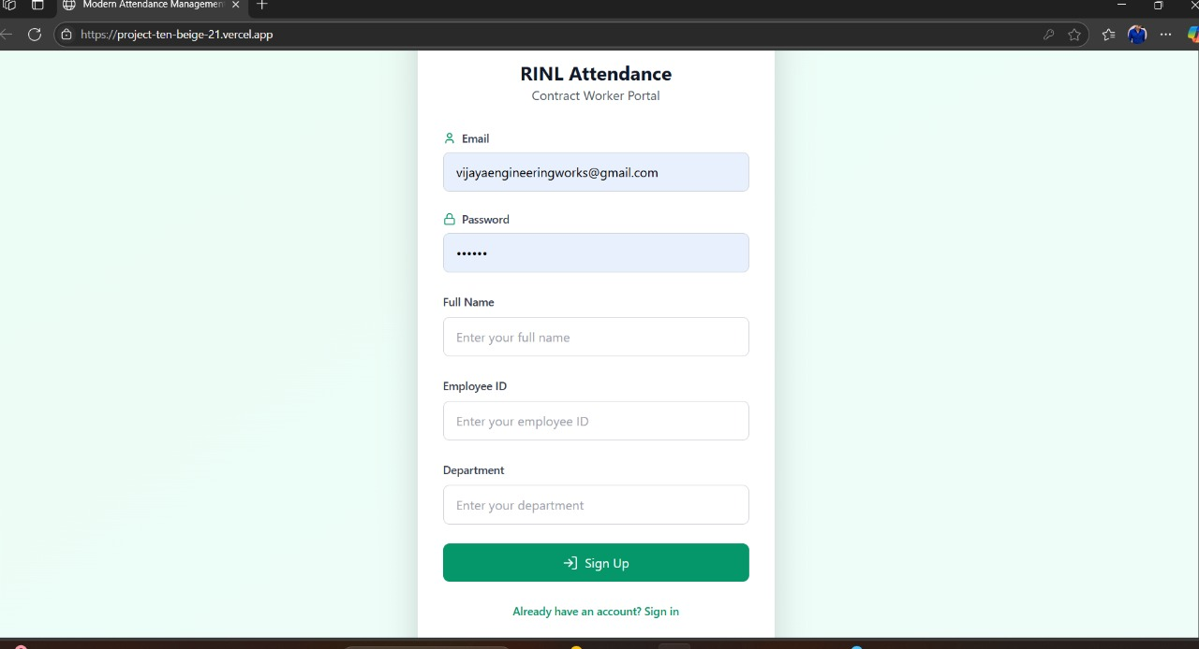

Login:

Accepts registered email & password.

Redirects to the dashboard upon success.

Invalid credentials display relevant error messages.

Security:

Frontend validations for input sanitization.

Backend token/session-based authentication (JWT or Firebase Auth assumed).

Passwords securely hashed (if backend uses own auth system).

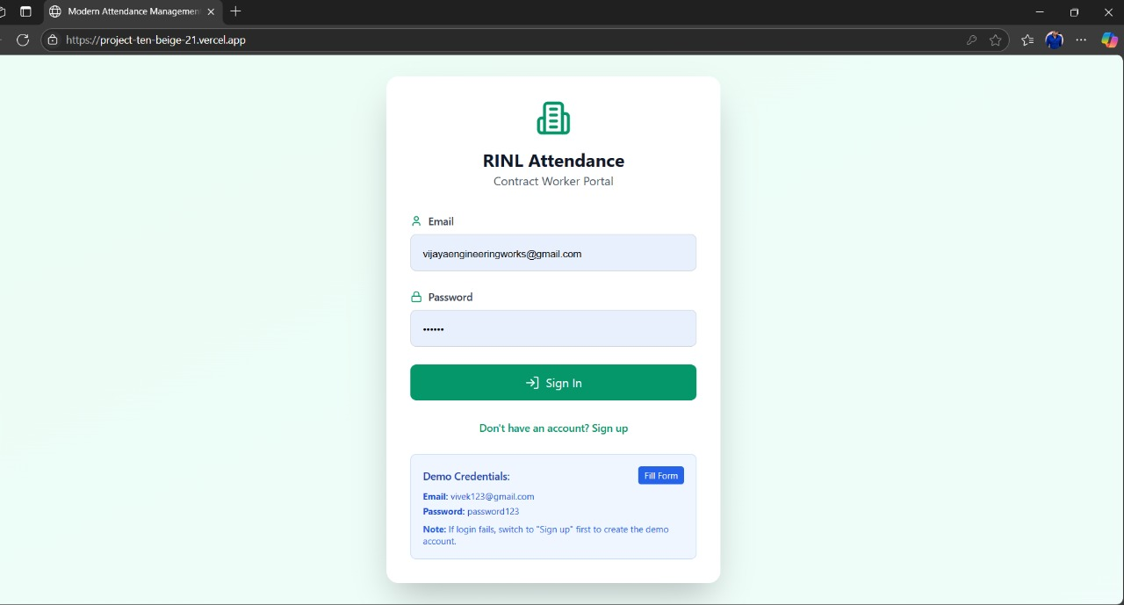

Worker Management Module

Purpose:

Handles onboarding and managing records of contract workers employed under various RINL departments.

Interface Overview:

List View of Workers:

Columns include:

- Name
- Aadhaar Number
- Skill Level (SK / SSK / USK)
- Gate Pass Number
- Pass Expiry Date

Actions:

- 🖊 Edit
- 🗑 Delete

Add Worker Form:

Inputs:

- Name
- Aadhaar Number (12-digit validation)
- Skill Category
- Gate Pass Number
- Gate Pass Validity
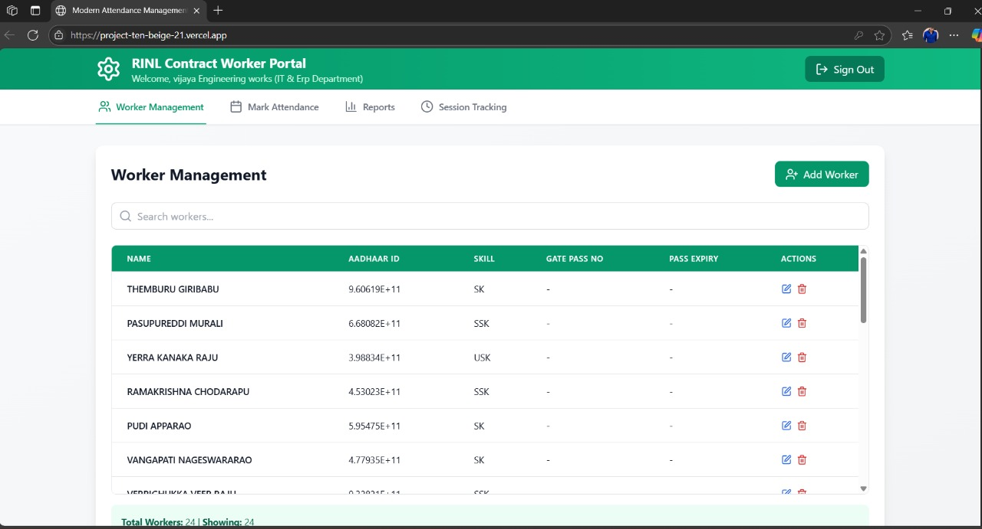

Attendance Tracking Module

Purpose:

Enables departments to record daily attendance of contract workers efficiently.

Features:

- Displays list of registered workers.

- Checkboxes to mark presence per worker for selected date.

- Automatic timestamping of attendance data.

- Restricts duplicate entries for the same date.

User Experience:

- Minimalist and responsive UI.

- Quick batch attendance marking.

- Visual confirmation after submission.

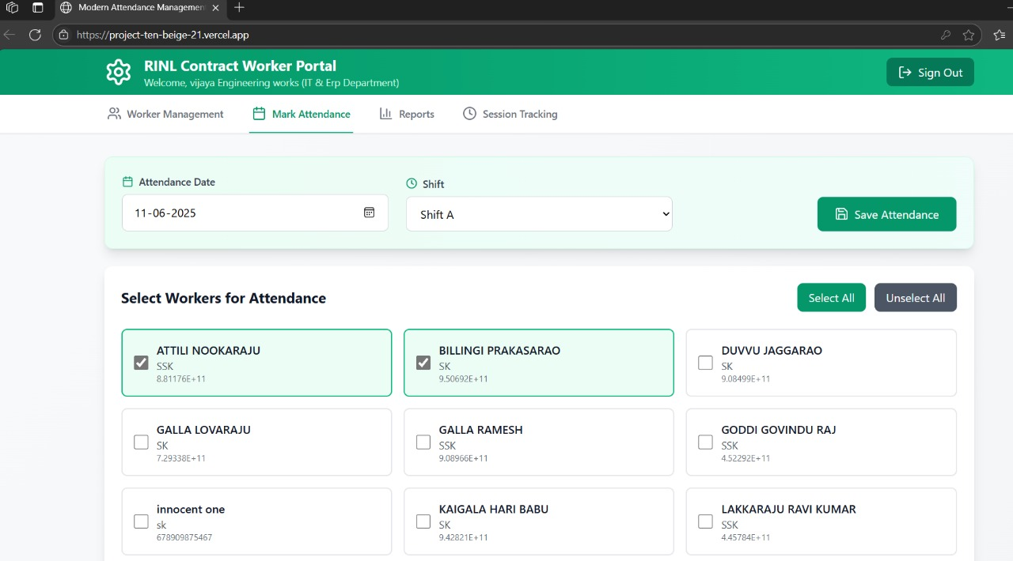

Attendance Reports & Analytics Module

Purpose:

To view, analyze, and export attendance trends over customizable time ranges.

Features:

- Date Range Selection:
Start Date & End Date (via calendar picker)

- Worker Filter:
All workers or specific worker

- Stats Display:
Total Workers

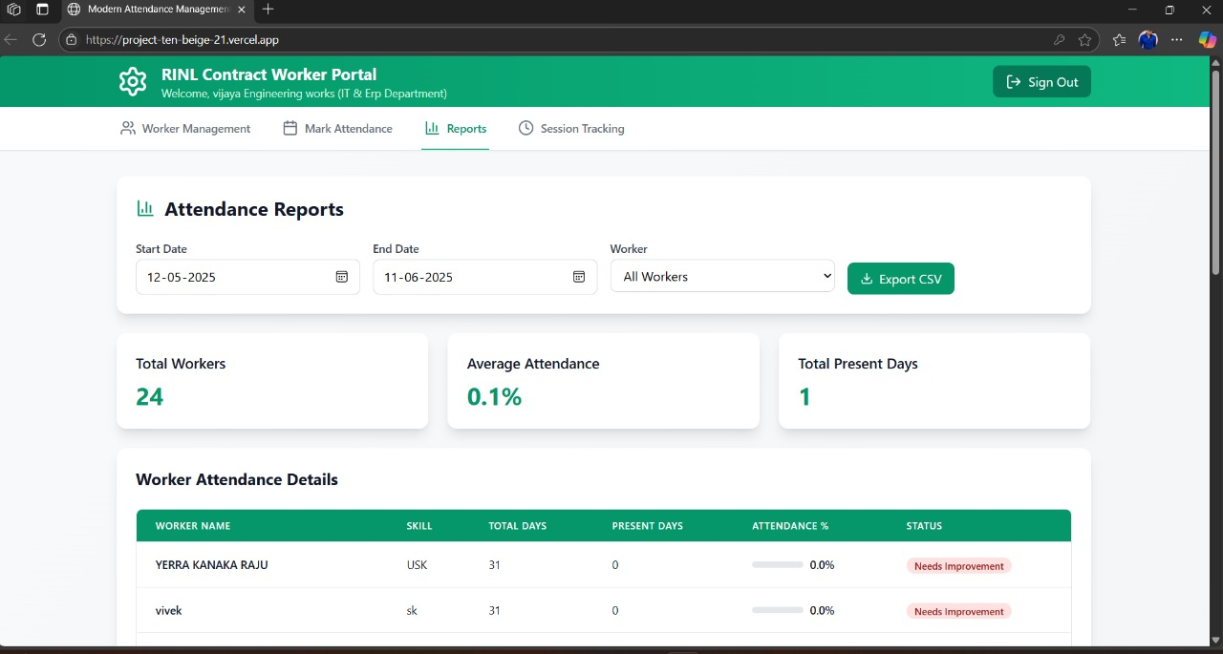

Average Attendance (%)

- Total Days Tracked

- Total Present Days

Attendance Table:

Worker Name Skill Total Days Present Days Attendance % Status

Rajesh K SK 25 21 84% Satisfactory
Ali B USK 25 15 60% Needs Attention

Export CSV:

- One-click CSV download of report data

- Useful for audits and offline reporting

Session Tracking Module (Planned / Placeholder)

Purpose:

To monitor work hours or session durations for each worker per day.

Potential Use-Cases:

- Clock-in and Clock-out logs

- Total working hours calculation

- Overtime tracking

Status:

Present as a navigation item in UI

Functionality not fully implemented as of now

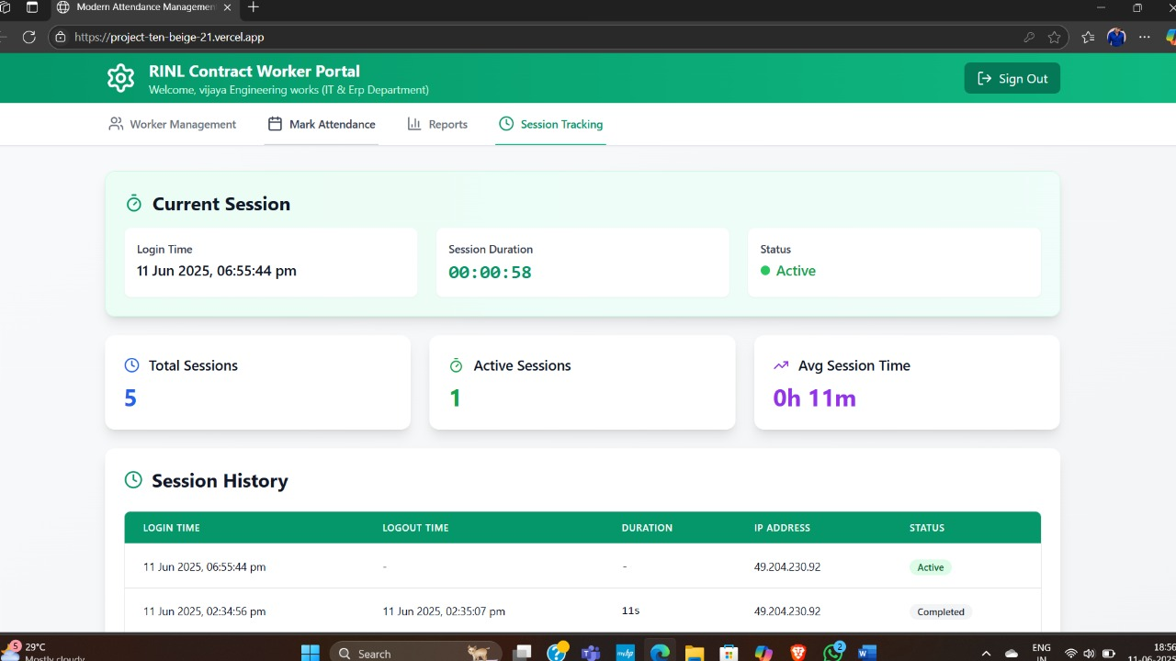

CONCLUSION

The "Gate Pass Management System" project, as evidenced by the provided screenshots, successfully implements a digital solution for controlling and tracking personnel within a facility. It effectively integrates a "Workers Info" module for managing detailed individual profiles (including IDs, contact, and contractor affiliations) with an "Attendance Page" that facilitates both manual and bulk (via Excel upload) recording of in/out times and device usage. This comprehensive approach enhances security through improved record-keeping and boosts operational efficiency by automating key aspects of personnel tracking, ultimately providing a transparent and accessible system for monitoring who is present and when.

REFERENCES

https://nodejs.org/en/docs/
https://expressjs.com/
https://dev.mysql.com/doc/
https://www.w3schools.com/

GLOSSARY

HTML
CSS
JAVASCRIPT
NODE JS
EXPRESS JS
MYSQL
All the above mentioned are the names of different web scripting languages used in the development.

